## CHANDIGARH UNIVERSITY

## UNIVERSITY INSTITUTE OF NGINEERING

**DEPARTMENT OF COMPUTER SCIENCE & ENGINEERING**



|  |  |
| --- | --- |
| **Submitted By: Submitted To:**  Vivek Kumar(21BCS8129) Neha Dutta(E12830) | |
| **Subject Name** | Design and Analysis of Algorithm Lab |
| **Subject Code** | 20CSP-312 |
| **Branch** | Computer Science and Engineering |
| **Semester** | 5th |

**Experiment - 3**

**Student Name: Vivek Kumar UID: 21BCS8129**

**Branch: BE-CSE(LEET) Section/Group: 20BCS-WM-616/A**

**Semester: 5th Date of Performance: 16/08/2022**

**Subject Name: DAA Lab Subject Code: 20CSP-312**

**1. Aim/Overview of the practical:**

Code to find frequency of elements in a given array in O(n) time complexity.

**2. Task to be done/ Which logistics used:**

To find the frequency of element in array using for loop.

**3. Requirements (For programming-based labs):**

* Laptop or PC.
* Operation system (Mac, Windows, Linux, or any)
* Vs-Code with MinGw or any C++ Compiler

**4. Algorithm/Flowchart (For programming-based labs):**

Step 1: Let us make an array of size n taken by user.

Step 2: Put the values in it.

Step 3: Make a variable freq=1 and idx=1 and element=arr[0].

Step 4: Now run a while loop to compare arr[idx-1] with arr[idx] if they are equal then increment of freq and ldx by 1 is their else print frequency of the element.

Step 5: Run the while loop till idx<n.

Step 6: Finish.

**5. Steps for experiment/practical/Code:**

#include <bits/stdc++.h>

using namespace std;

void countFreq(int arr[], int n)

{

    vector<bool> visited(n, false);

    for (int i = 0; i < n; i++)

    {

        if (visited[i] == true)

            continue;

        int count = 1;

        for (int j = i + 1; j < n; j++)

        {

            if (arr[i] == arr[j])

            {

                visited[j] = true;

                count++;

            }

        }

        cout << arr[i] << " - " << count << endl;

    }

}

int main()

{

    int i, size;

    cout << "Enter the Size of array: ";

    cin >> size;

    int arr[size];

    cout << "Enter the array elements:\n";

    for (i = 0; i < size; i++)

        cin >> arr[i];

    cout << "Number of frequency is as follows\n";

    countFreq(arr, size);

    return 0;

}

**6. Output:**

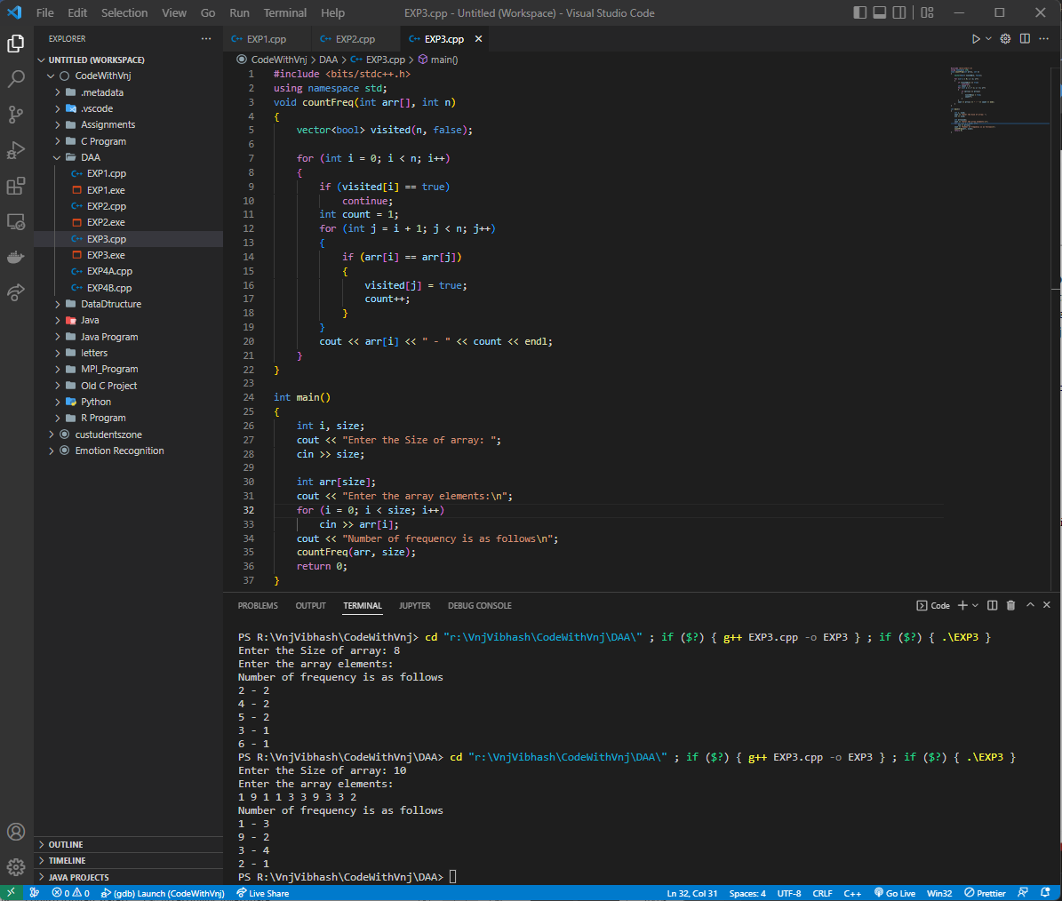



**Learning outcomes (What I have learnt):**

1. How to Enter the elements in an Array.
2. How to use for loop.
3. How to find the frequency of a number in given Array.

**Evaluation Grid (To be created per the faculty's SOP and Assessment guidelines):**

|  |  |  |  |
| --- | --- | --- | --- |
| Sr. No. | Parameters | Marks Obtained | Maximum Marks |
| 1. | Worksheet completion including writing learning objectives/Outcomes.  (To be submitted at the end of the day). |  |  |
| 2. | Post-Lab Quiz Result. |  |  |
| 3. | Student Engagement in  Simulation/Demonstration/Performance and Controls/Pre-Lab Questions. |  |  |
|  | Signature of Faculty (with Date): | Total Marks Obtained: |  |